North Wall Zone B - PLAN VIEW

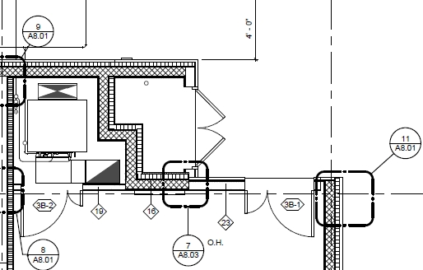

**N2**

Door Wall

<23>  
(1.37m)

**N7**

Int Door Head Wall   
(1.22 m)

**N6**

<19>   
(0.827m)

**N3** Door Wall<23>  
(0.89 m)

**N1**

K-Wall North Corner (0.65m)

**N8**

J-Wall North Corner (0.36 m)

**N4 & N5**<16> & 7/A8.03  
(1.45m)

The Plan view is in 1/A2.03 in the file “ARCH - RECORD SET_AS BUILT”

The Elevation view is 1/S3.3 in the file Structural.pdf.

N2 and N3 Are combined and modeled as Door Wall as below

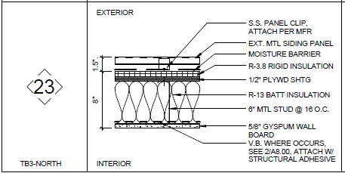

The Head and Sill U values are the same as intermediate section

ELEVATION VIEW

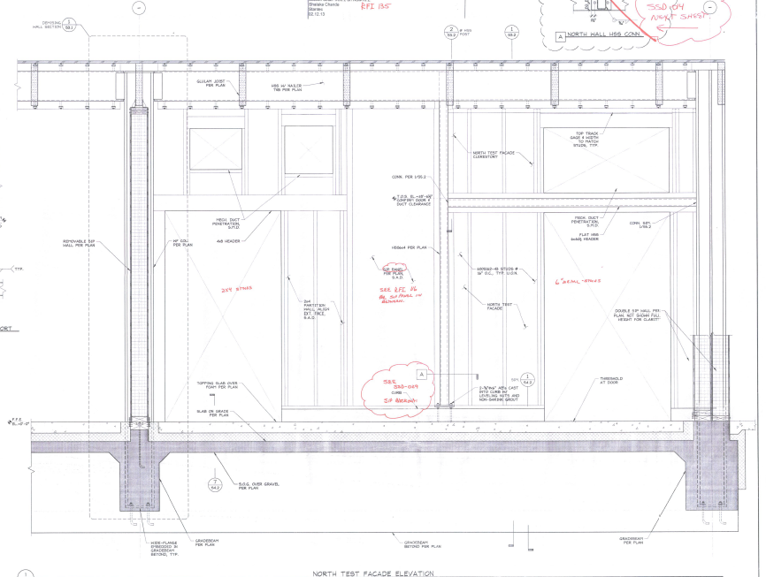

**N1 Section**

This is the corner section of K-wall north. The length is 0.65 meters.

**N2 Section**

This section is the same as <23> in the document “Pages from ARCH - RECORD SET_AS BUILT.pdf” Page A8.01 The length is 1.37 m.

**N3 Section**

This section is <23> in the document “Pages from ARCH - RECORD SET_AS BUILT.pdf” Page A8.0. The length is 0.85 m.